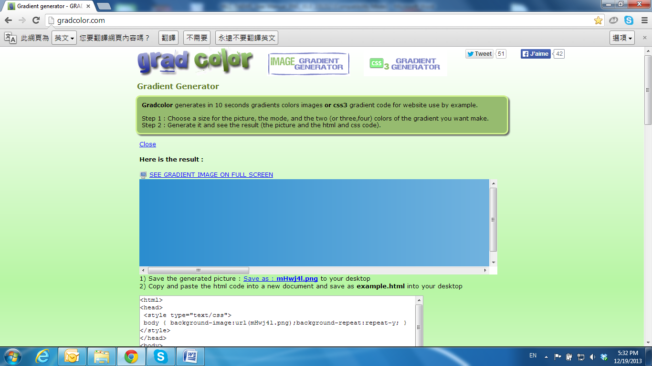

Universal Password

If you forgot the password of your IP camera, you can reset the camera to factory default, or follow the procedure below to generate a universal password.

**Note:** Universal password will be valid only when you enable the function in **User Management.**

1. First, you need to know the IP address and MAC address of your IP camera. You can use **IP installer** to scan the LAN, and see the IP address and MAC address on the side column.

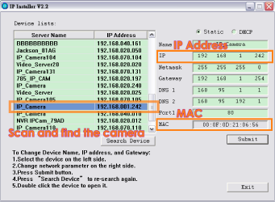

Or, if you already know the IP address of camera: Open the web browser, key in **http:// (IP address) /GetIPMAC.cgi** and press enter. The IP address and MAC address will be displayed on browser.

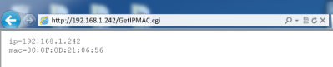

1. Find the .html file named **Universal Password** in CD-ROM. Click to open it.

up4

1. Key in the camera IP address **IP Address** column and MAC address in **MAC** column, and then click **encoder**, a set of username and password will appear, as shown in the picture below:

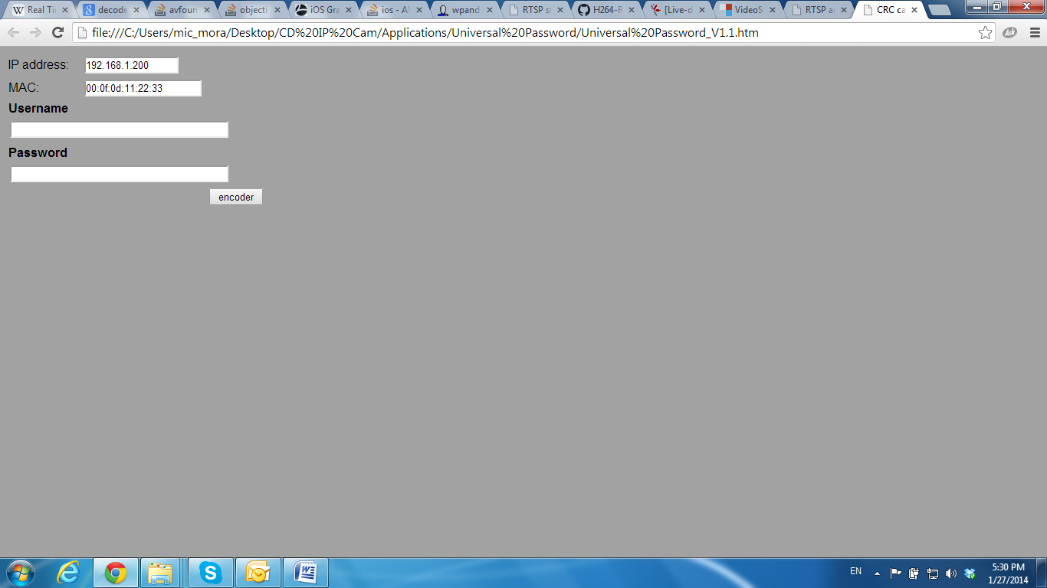

The universal username and password are generated from the IP address and MAC address you key-in, so if you change the camera IP address the universal password changes, too.

1. 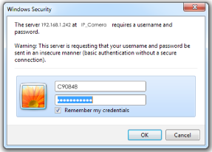Take the generated username and password. Use them to log into the camera.
2. Now you can login as administrator. Turn to **User Management** page. The use of universal password does not affect the previous user setting, so the administrator account password does not change until you edit it. Please click **Edit** to give a new administrator password.

